**ASSIGNMENT-1**

**1. Write a Python program to calculate the area of a rectangle given its length and width.**

**ANS:**

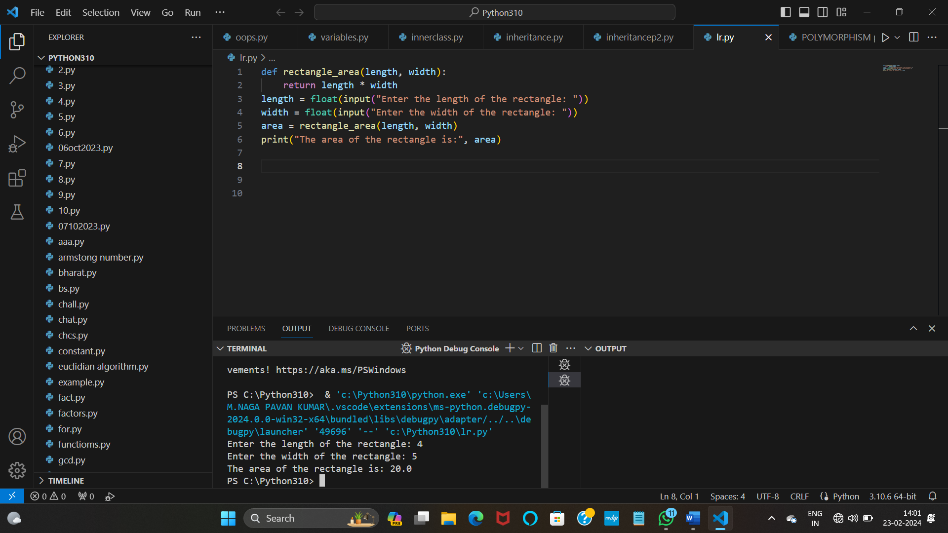

**2. Write a program to convert miles to kilometers**

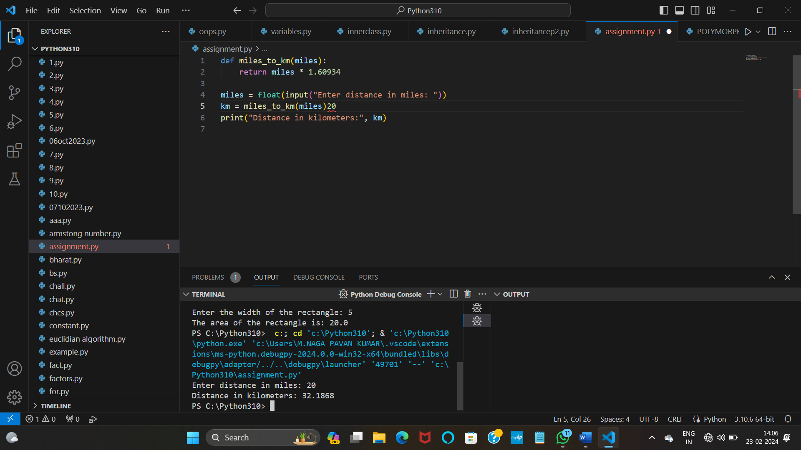

**3. Write a function to check if a given string is a palindrome.**

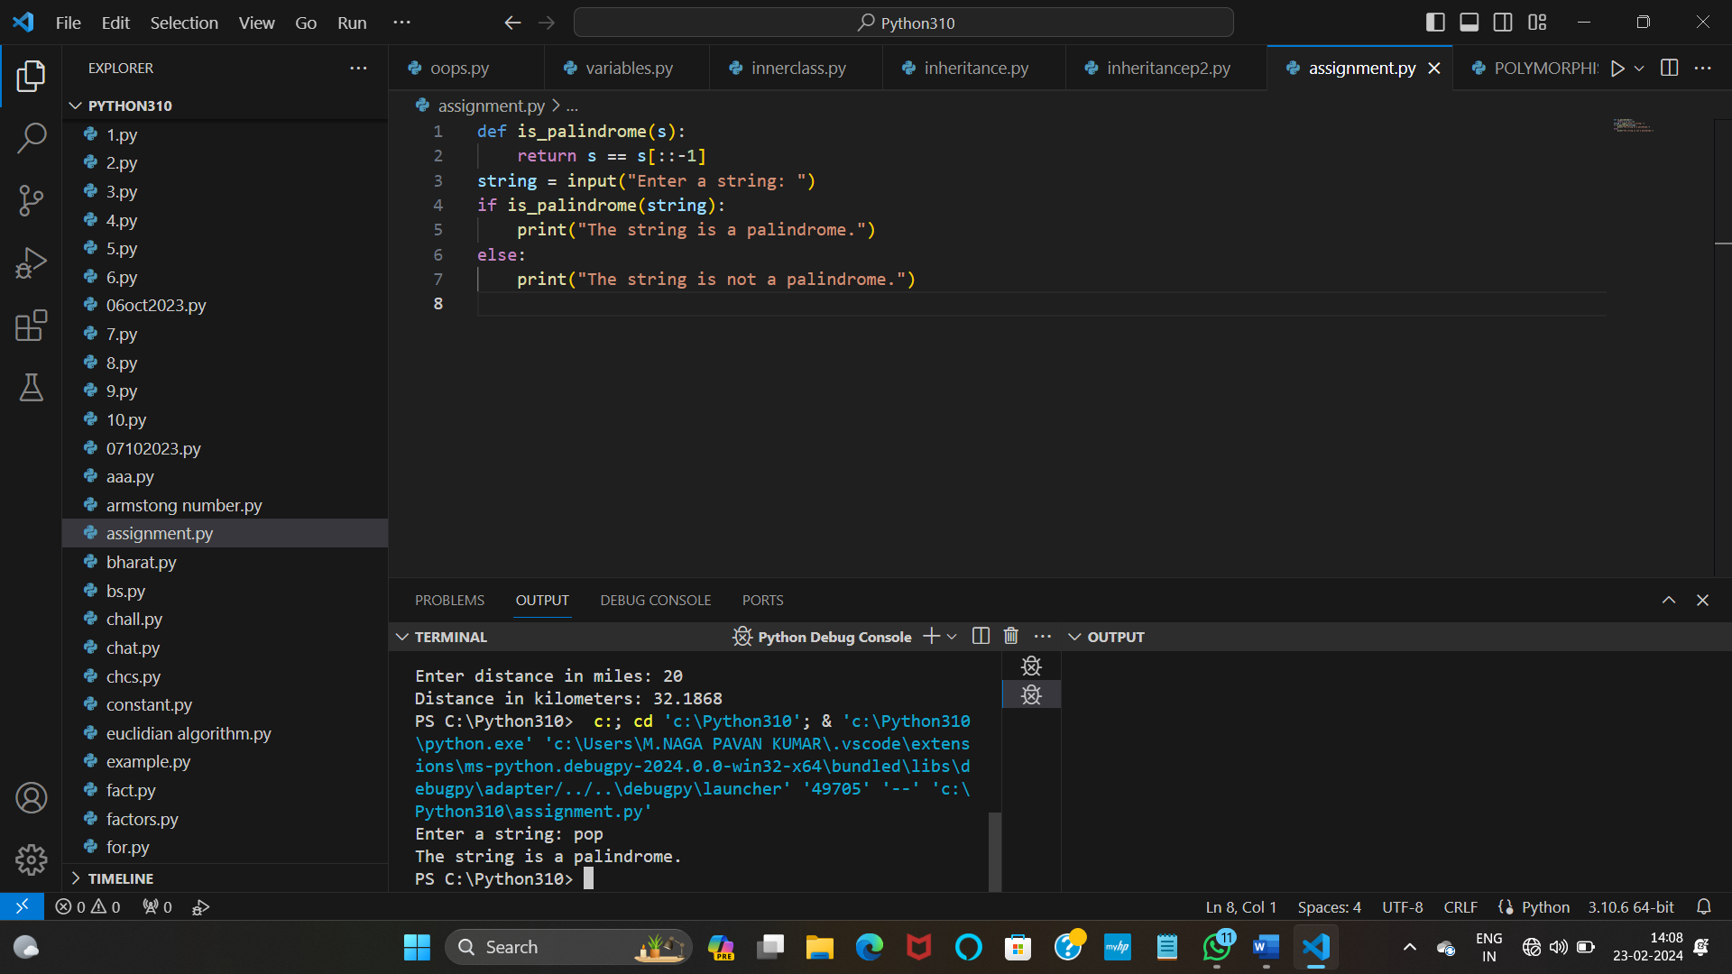

**4. Write a Python program to find the second largest element in a list.**

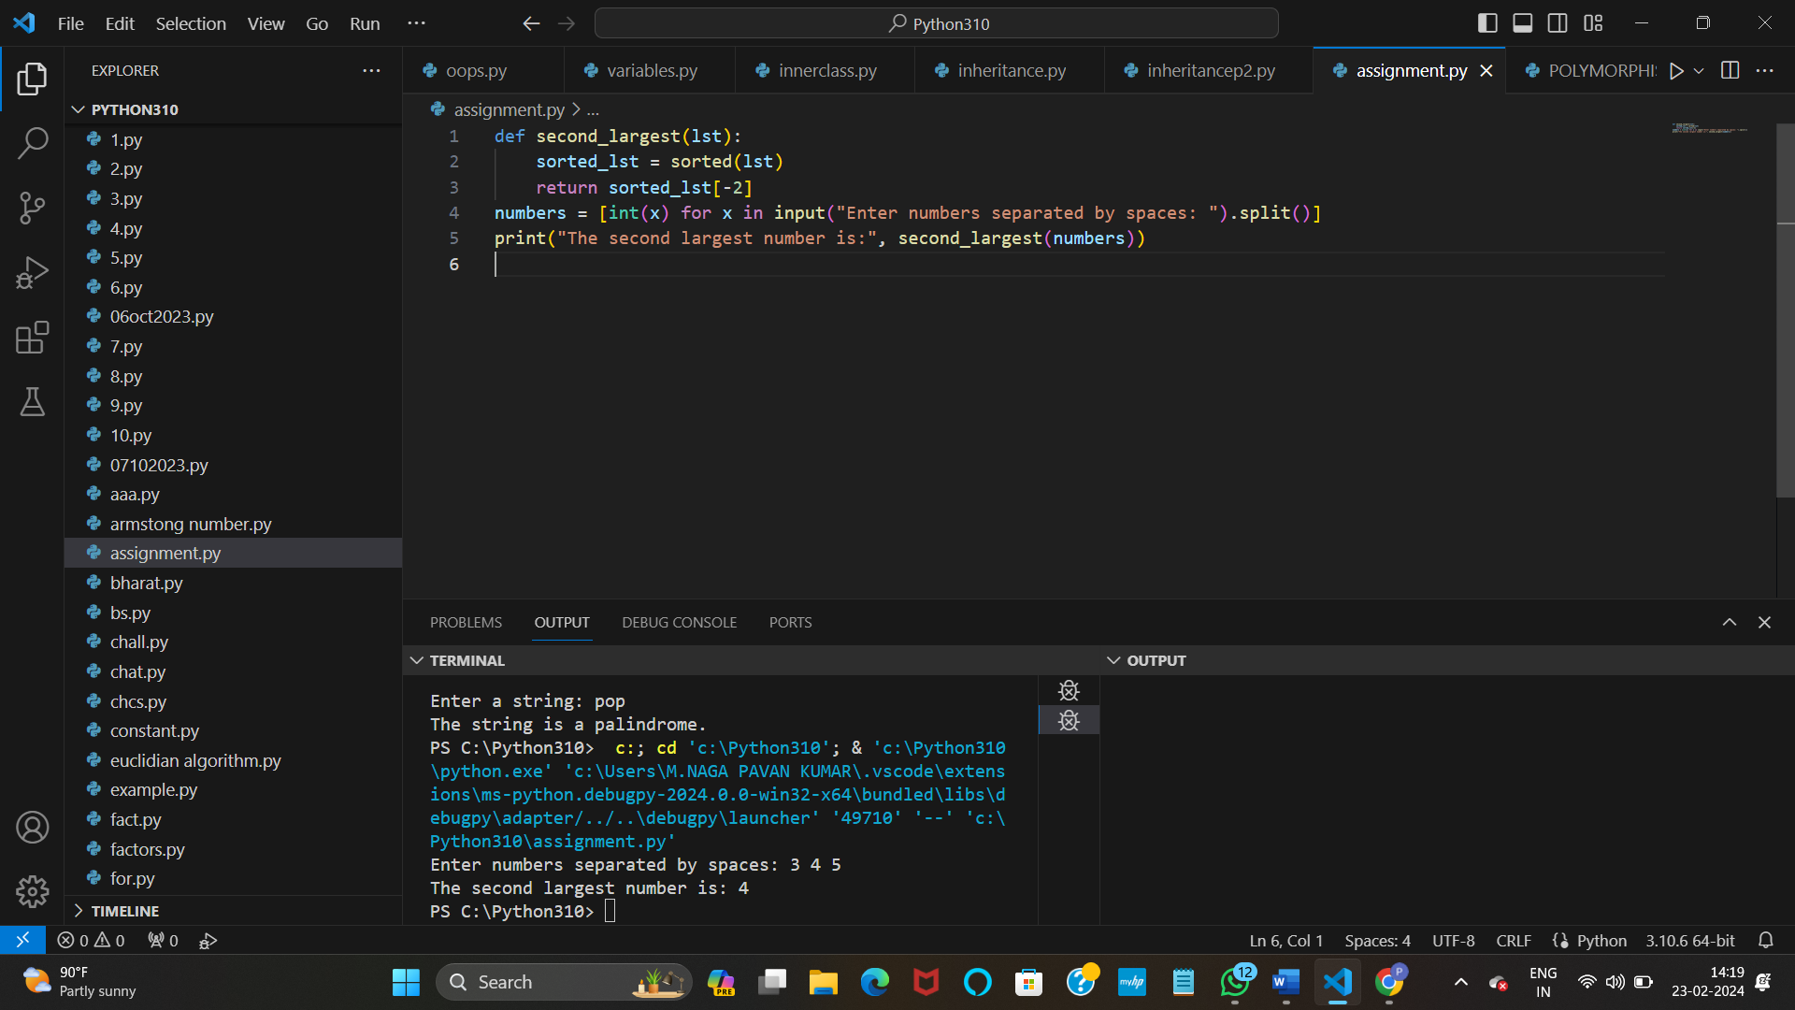

**5. Explain what indentation means in Python.**

Indentation in Python:

Indentation in Python is used to define blocks of code. It is crucial for defining the structure and hierarchy of code, such as loops, conditional statements, and function definitions. Proper indentation is necessary for Python to understand the logical structure of the code.

**6. Write a program to perform set difference operation.**

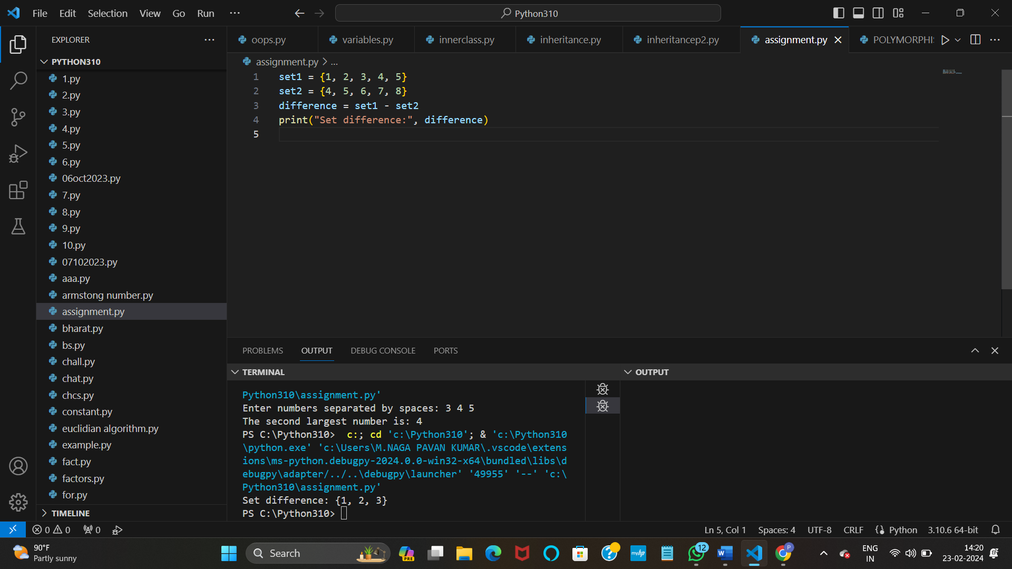

**7. Write a Python program to print numbers from 1 to 10 using a while loop**

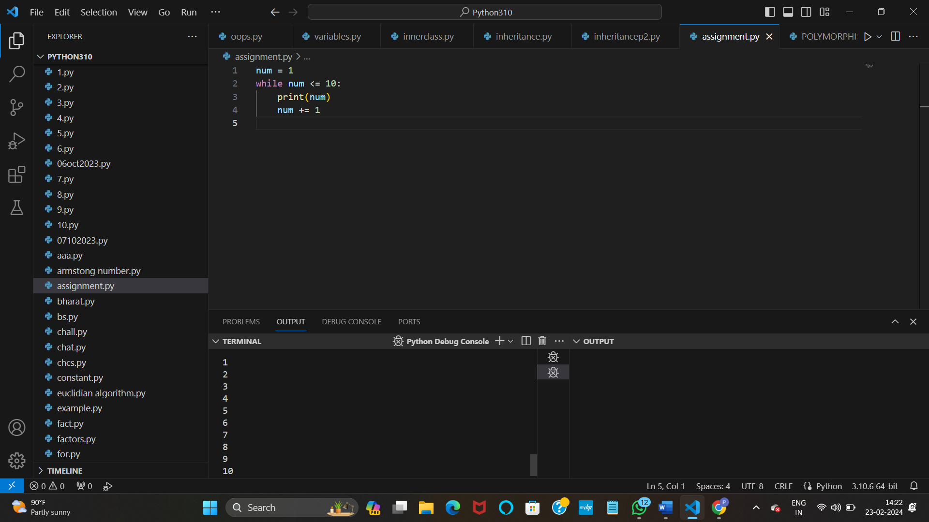

**8. Write a program to calculate the factorial of a number using a while loop**.

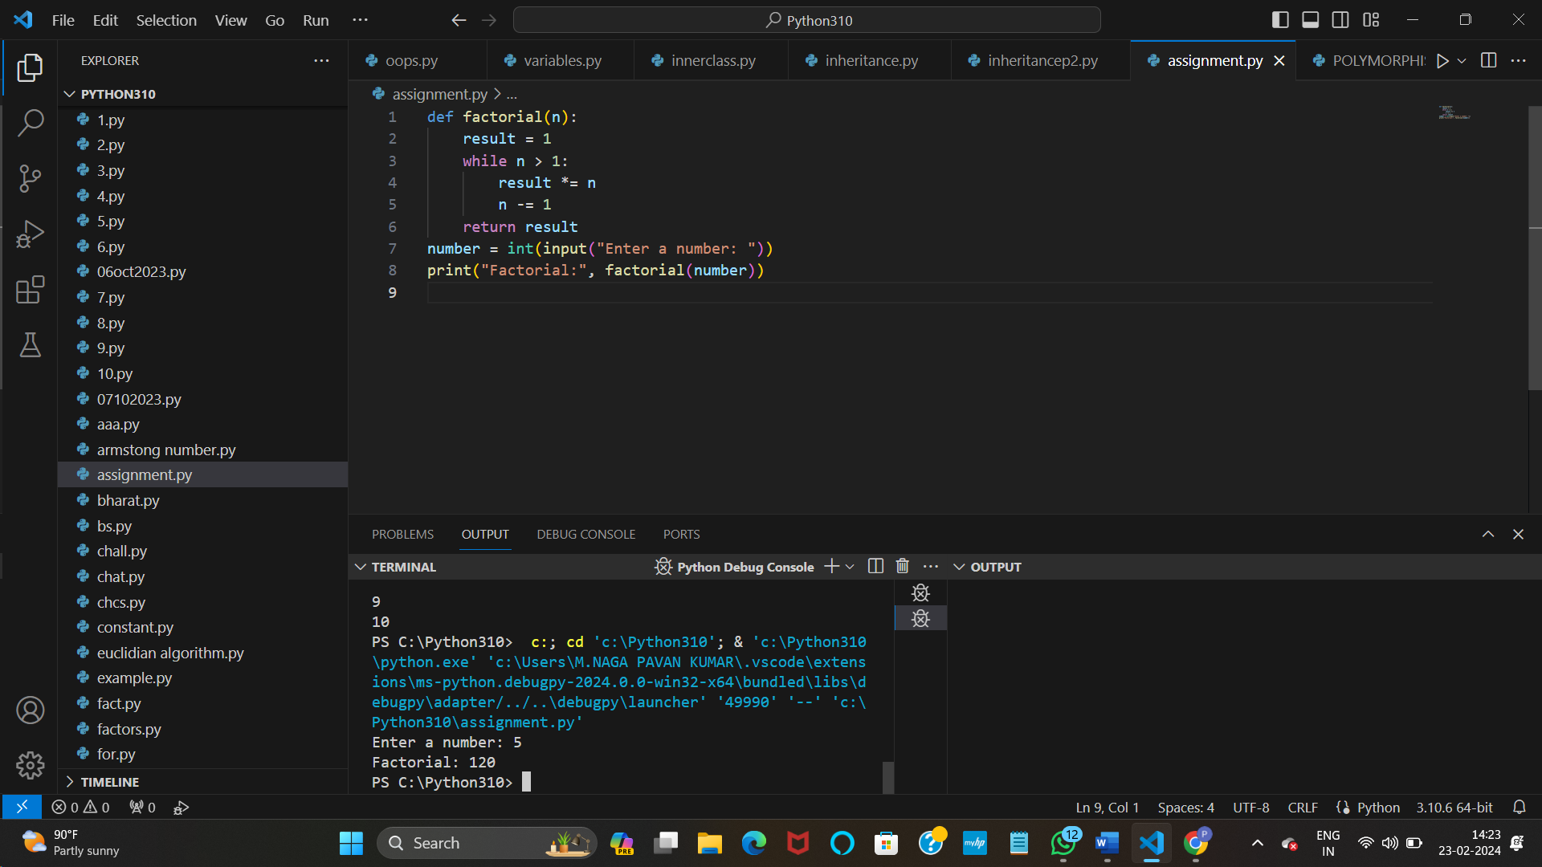

**9. Write a Python program to check if a number is positive, negative, or zero using if-elif-else statements.**

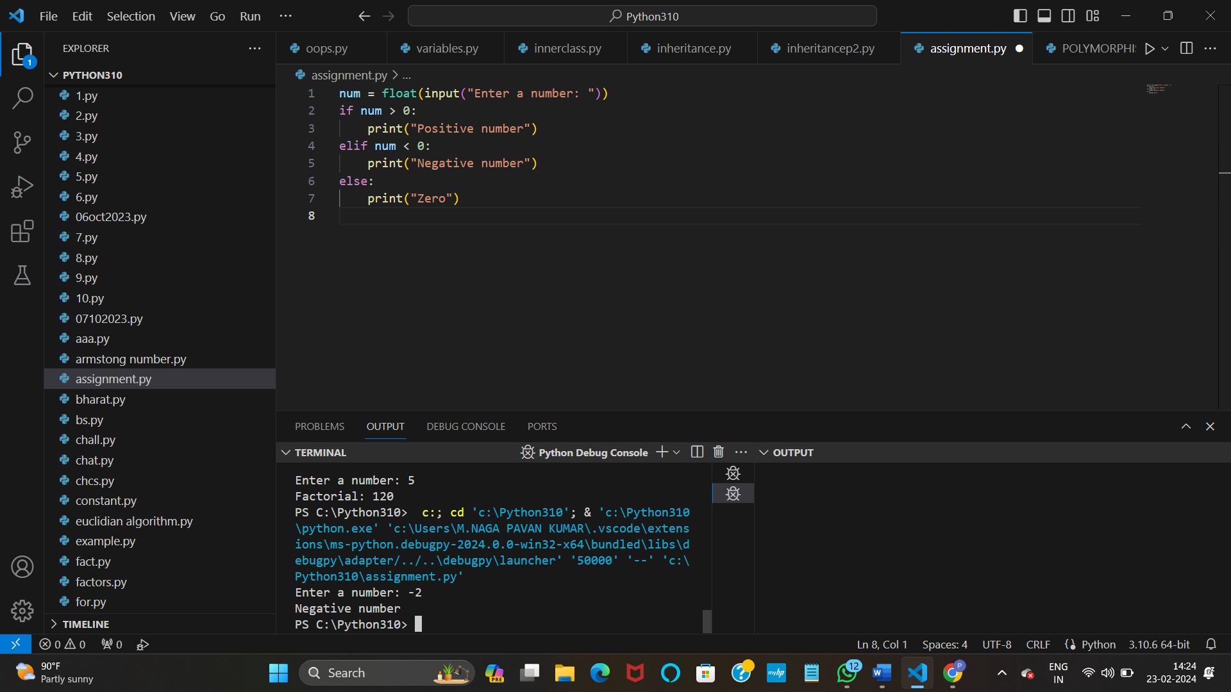

**10. Write a program to determine the largest among three numbers using conditional statements.**

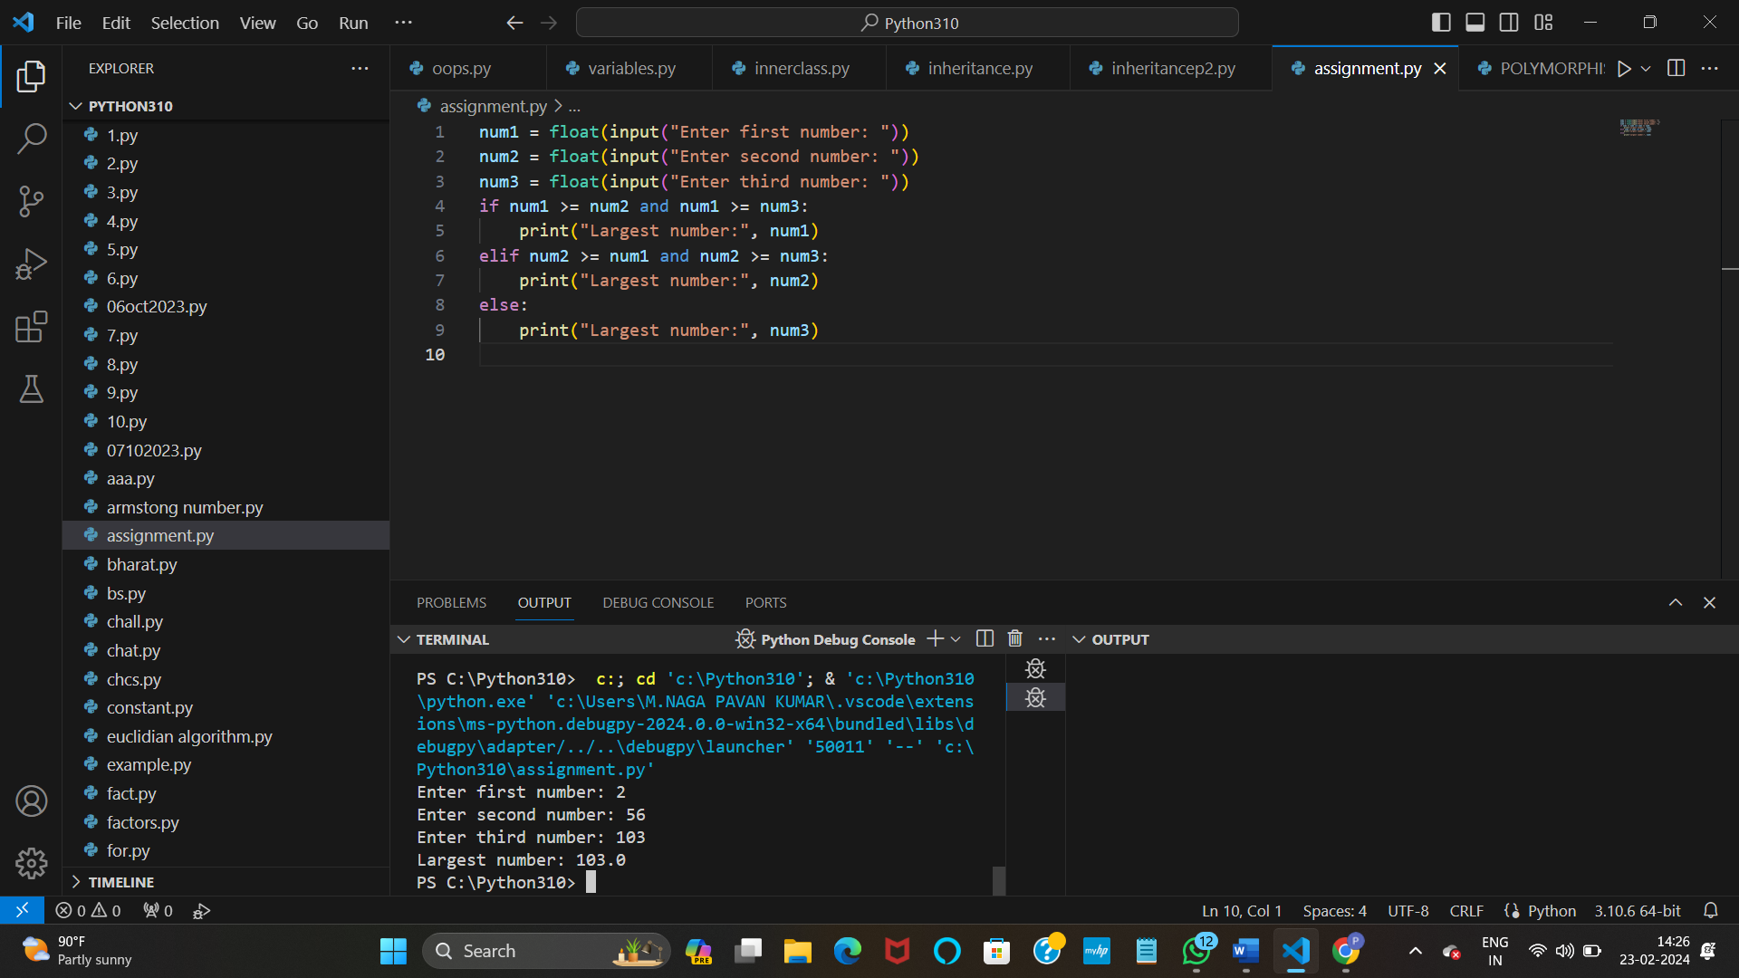

**11. Write a Python program to create a numpy array filled with ones of given shape.**

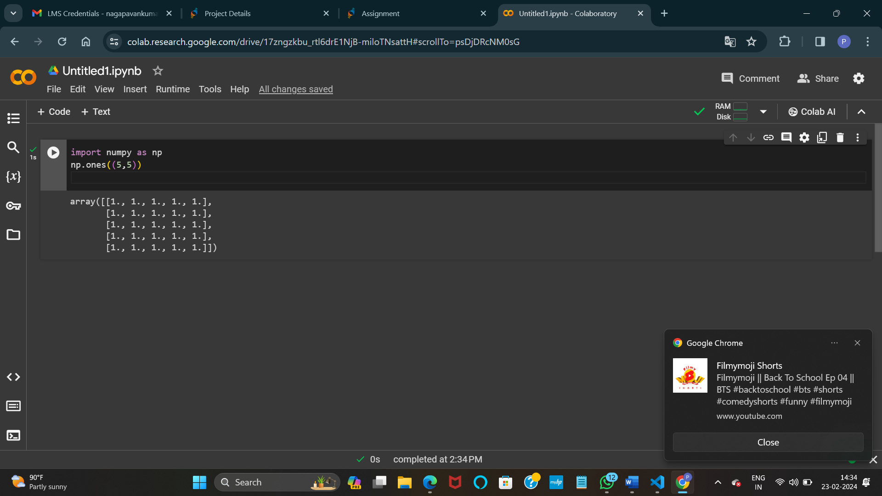

**12. Write a program to create a 2D numpy array initialized with random integers**

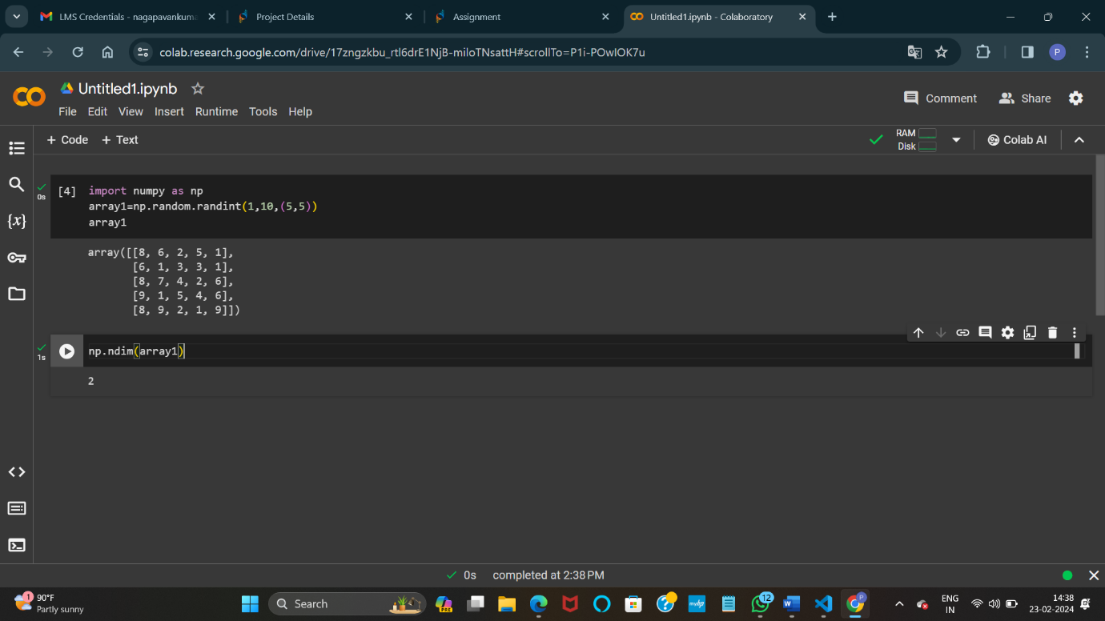

**13. Write a Python program to generate an array of evenly spaced numbers over a specified range using linspace.**

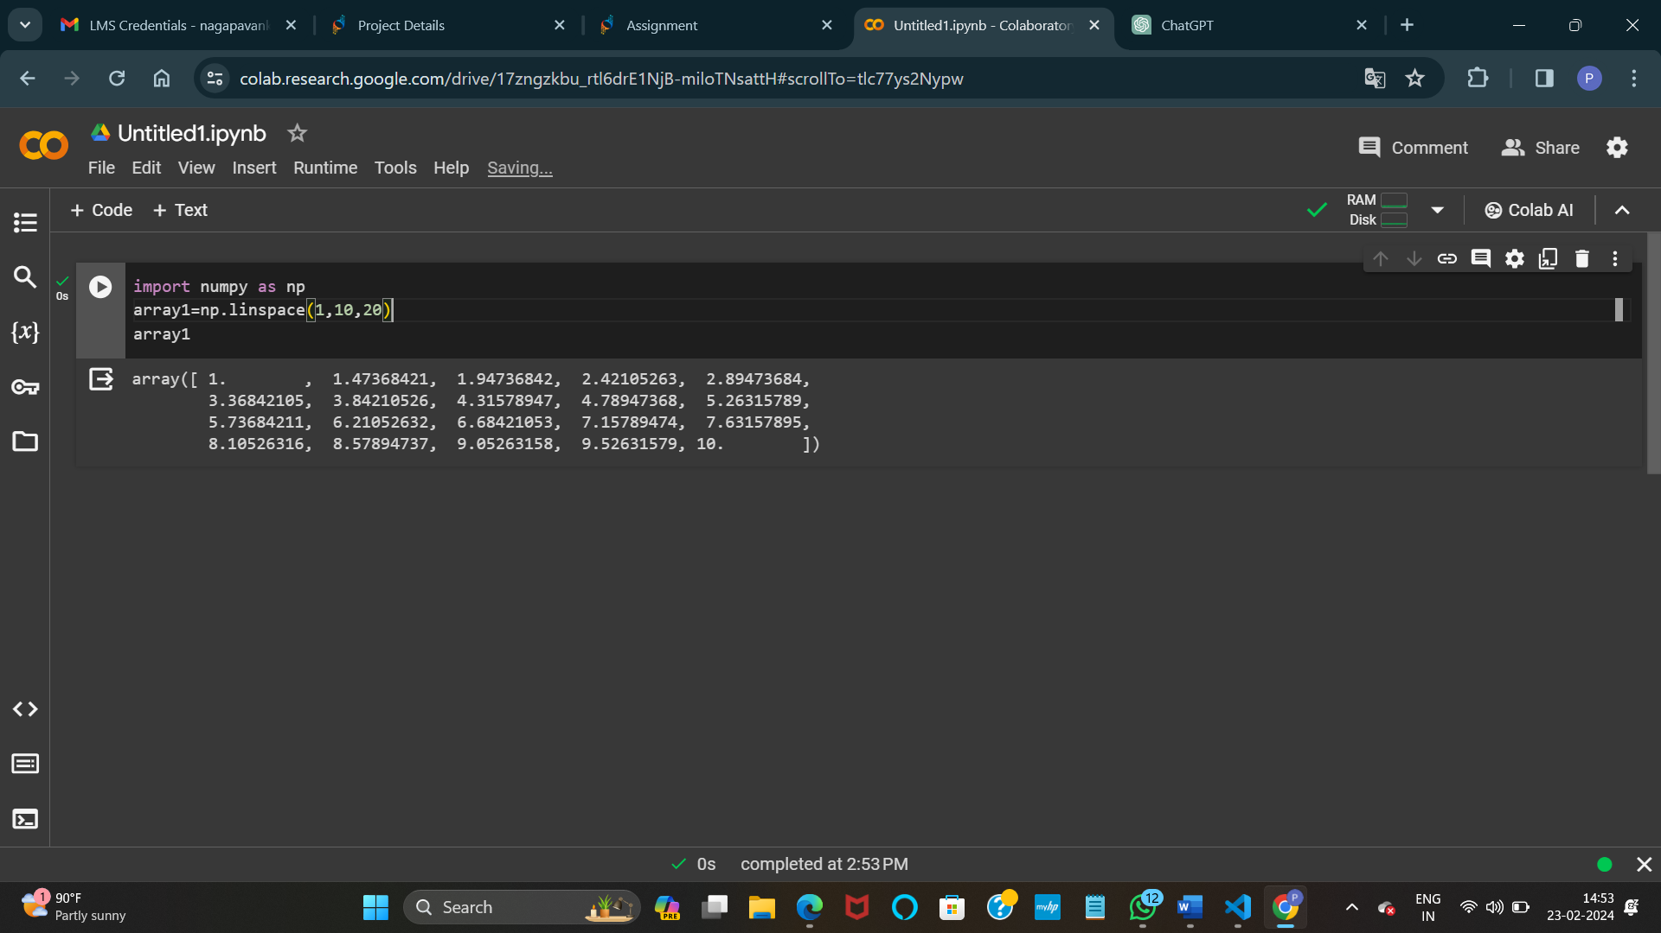

**14. Write a program to generate an array of 10 equally spaced values between 1 and 100 using linspace.**

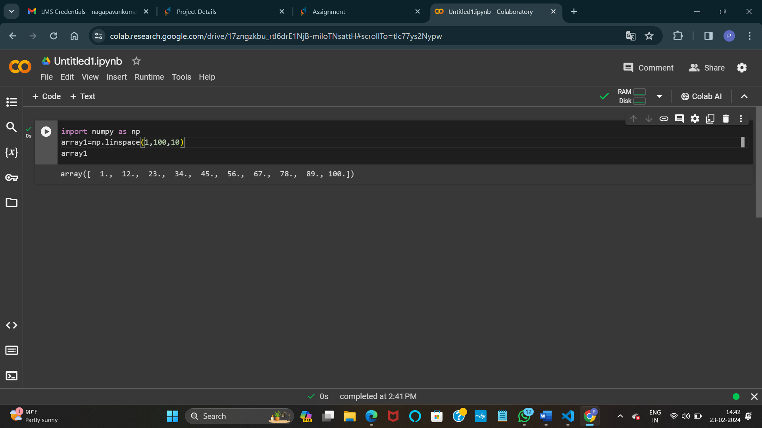

**15. Write a Python program to create an array containing even numbers from 2 to 20 using arange.**

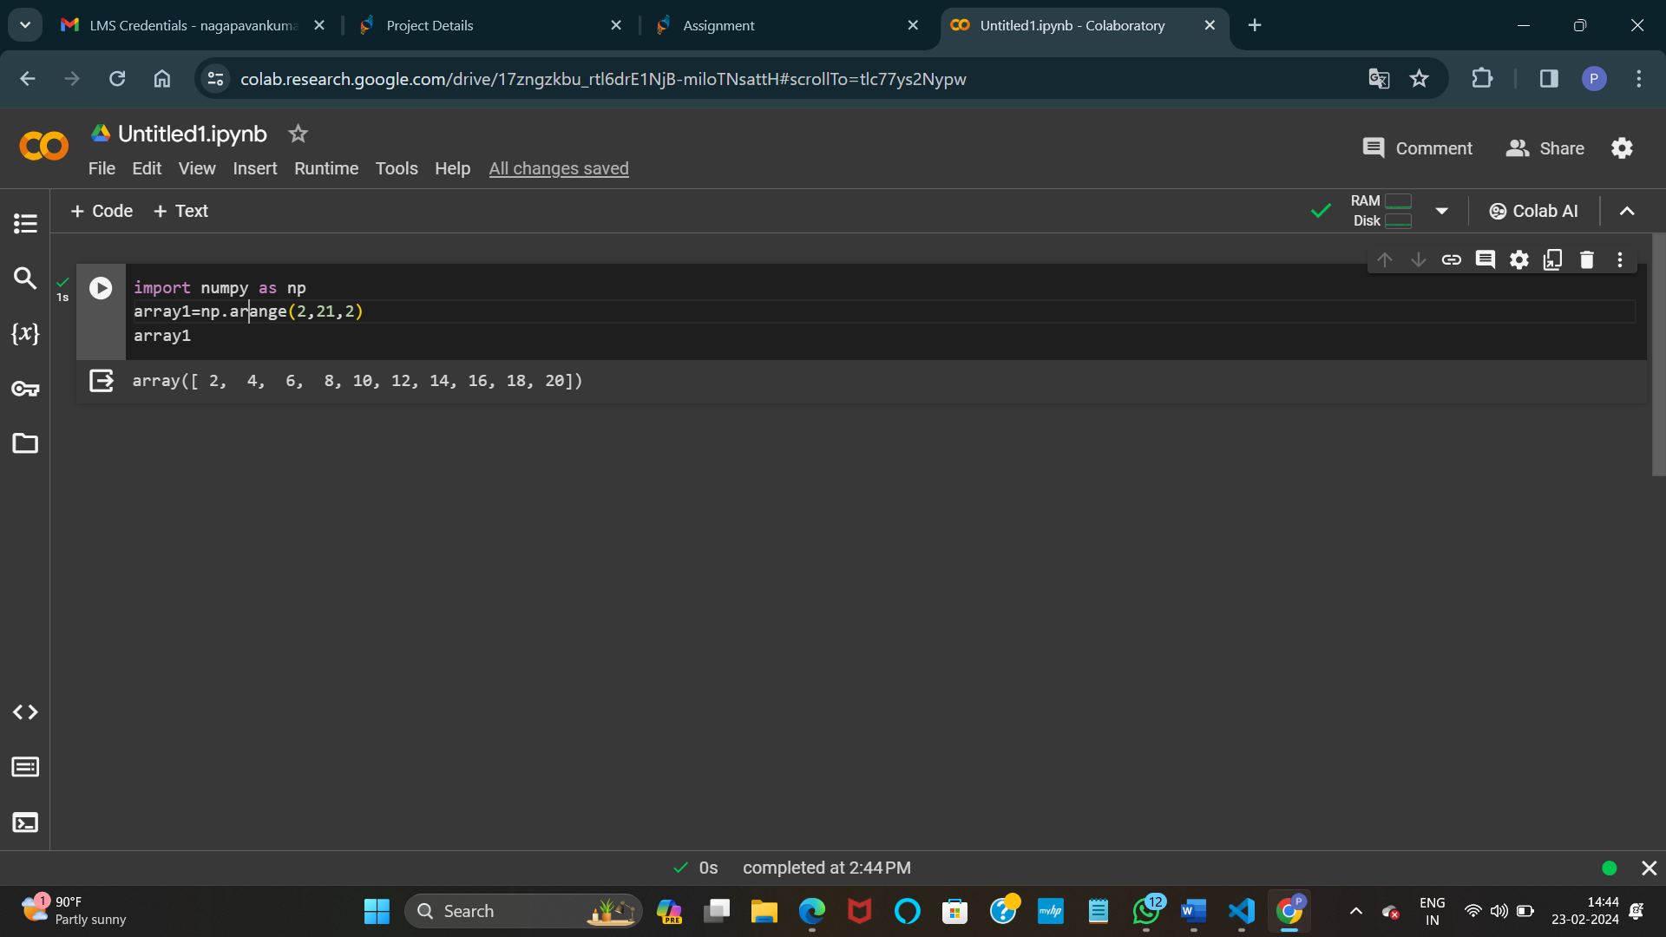

**16. Write a program to create an array containing numbers from 1 to 10 with a step size of 0.5 using arange.**

